ST10438801- Yamika Govender

PROG7311 POE PART 1

In a general context, Global logistics management refers to the entire process of planning, implementing, and controlling the movement of goods, services, and related information from the source to the consumer. (Site Point GmbH, 2025). In this context, the Global Logistics System will focus on handling complex relationships between clients, contracts and service requests. (Site Point GmbH, 2025). The main goal of the project is to build a scalable Global Logistics Management System that can handle the complex relationships between clients, contracts and service requests for TechMove Logistics. The system must also be able to store legal agreements, client details and Service Level Agreements (SLAs), validate that requests are only raised against valid active contracts and can handle international currency conversions automatically.
The Open Group Architecture Framework (TOGAF) is an enterprise architecture method that provides an overall conceptual structure for developing corporate software. TOGAF assists in controlling the software development life cycle through a step, by, step method aimed at minimizing mistakes, delivering on time, not exceeding budget, and aligning IT with business divisions in order to produce high, quality results. (White. S, 2022). Two major divisions of the TOGAF framework are extended guidance and core content. Central content consists of the entire set of principles and practices of TOGAF that form the basis of the framework. (GeeksforGeeks ,2024). The enlarged guidance section of TOGAF deals with a variety of issues, e. g. business architecture, data and information architecture, security architecture, and agile methods. (GeeksforGeeks ,2024).
TOGAF is a more suitable choice for developing a Global Logistics Management System as it has a well, defined EA (Enterprise Architecture) method and architecture. Its modular structure allows for scaling the system across global locations. (Redhat ,2021). It provides a roadmap to transition from a fragmented legacy system to a consolidated system. (Redhat ,2021). Besides serving complicated legal contracts, it also provides an organized, comprehensive, and secure structure for handling highly complex issues and regulatory compliance. (vpadmin, 2024). Lastly, The TOGAF standard can assist businesses save time and money by eliminating redundancies, maximizing resources, and simplifying procedures. By utilizing already existing architectural resources, the framework's emphasis on reusability also contributes to cost savings. (vpadmin, 2024).

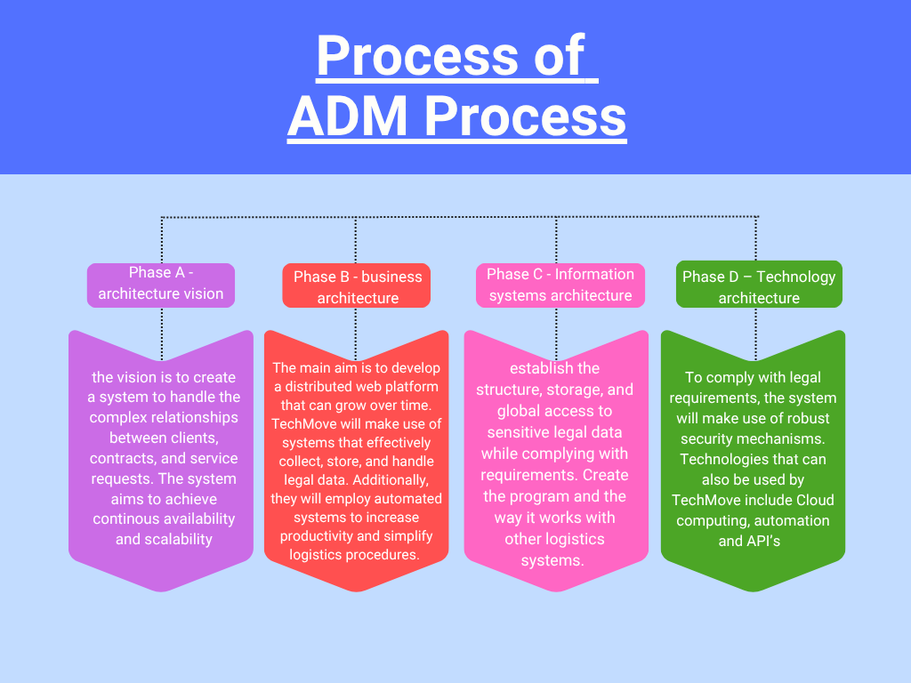

Gang of four patterns:

An object can modify its behaviour when its internal state changes because of the State Design Pattern, a behavioural design pattern. (GeeksforGeeks, 2017). It enables the object to effectively manage state transitions by encapsulating state-specific activity into distinct state classes. (GeeksforGeeks, 2017).
- How state patterns help with decoupling:

- Encapsulation: The State pattern creates separate classes for every state rather than one large class doing all validations. (Lee. S, 2025).
- Open/Closed Principle: You can add new states by simply creating new classes without changing code of existing states or context. (Lee. S, 2025).

- How state patterns help with validation problems:

- The pattern ensures that the logistics system follows a secure procedure that has been set in advance, which is crucial for the management of complex situations. (chloe and chloe, 2024).
- Rather than relying on one, big, and potentially error-prone if block, the pattern dismantles complex validation requirements of different lifecycle stages. (chloe and chloe, 2024).

- How I will use it in my code:

- An if/else statement will be used in my contract class, where, if a user gets a contract, then then will have to pay, else they won’t have to pay if they didn’t get a contract.
- An if/else statement will also be used for the Manager class, where if a service request is made in the ServiceRequest class, then a Manager can raise a service request, else they won’t be able to raise the service request.

A behavioural pattern known as the Observer Design Pattern establishes a one-to-many interaction between a subject and its observers. (GeeksforGeeks, 2016). All dependent observers are automatically informed and updated as the subject's status changes, guaranteeing continuous communication. (GeeksforGeeks, 2016).

- How Observer design patterns help with validation problems:

- New stakeholders / compliance rules can be added as observers at runtime, without changing any of the underlying logistical code. (DEV Community, 2021).
- The system receives these updates from regulatory modifications because of validation mechanisms. Additionally, it follows the open/closed principle. (GeeksforGeeks, 2016).
- Reusable, modular segments of validation logic. Regulations are subject to constant change or removal. This allows rules to change without changing the code and stabilizes essential functions. (DEV Community, 2021).
- How Observer design patterns help with decoupling:

- Eliminates the need for large and tightly coupled classes. (cpr_admin_1, 2024).
- Supports flexible and scalable workflows. (GeeksforGeeks, 2016).

- How I will use it in my code:

- Users will get notified when the status of a contract change and a service request
- They will also be notified when a service request is validated by the system

A structural design called the Decorator Design enables the dynamic addition of behaviour to specific objects. It improves functionality without changing the original class or having an impact on other items. (GeeksforGeeks ,2016).

- How Decorator Design patterns help with decoupling:

- Supports flexibility and scalability in system design. (GeeksforGeeks ,2016).
- Separates responsibilities as each decorator handles one feature. (Kumar. A, 2024).

- How Decorator Design patterns help with validation problems:

- Breaking down validation into reusable components. (Aamol Gote, 2014 ).
- Avoiding tightly coupled and complex logic. ( Aamol Gote ,2014).

UML Class Diagram
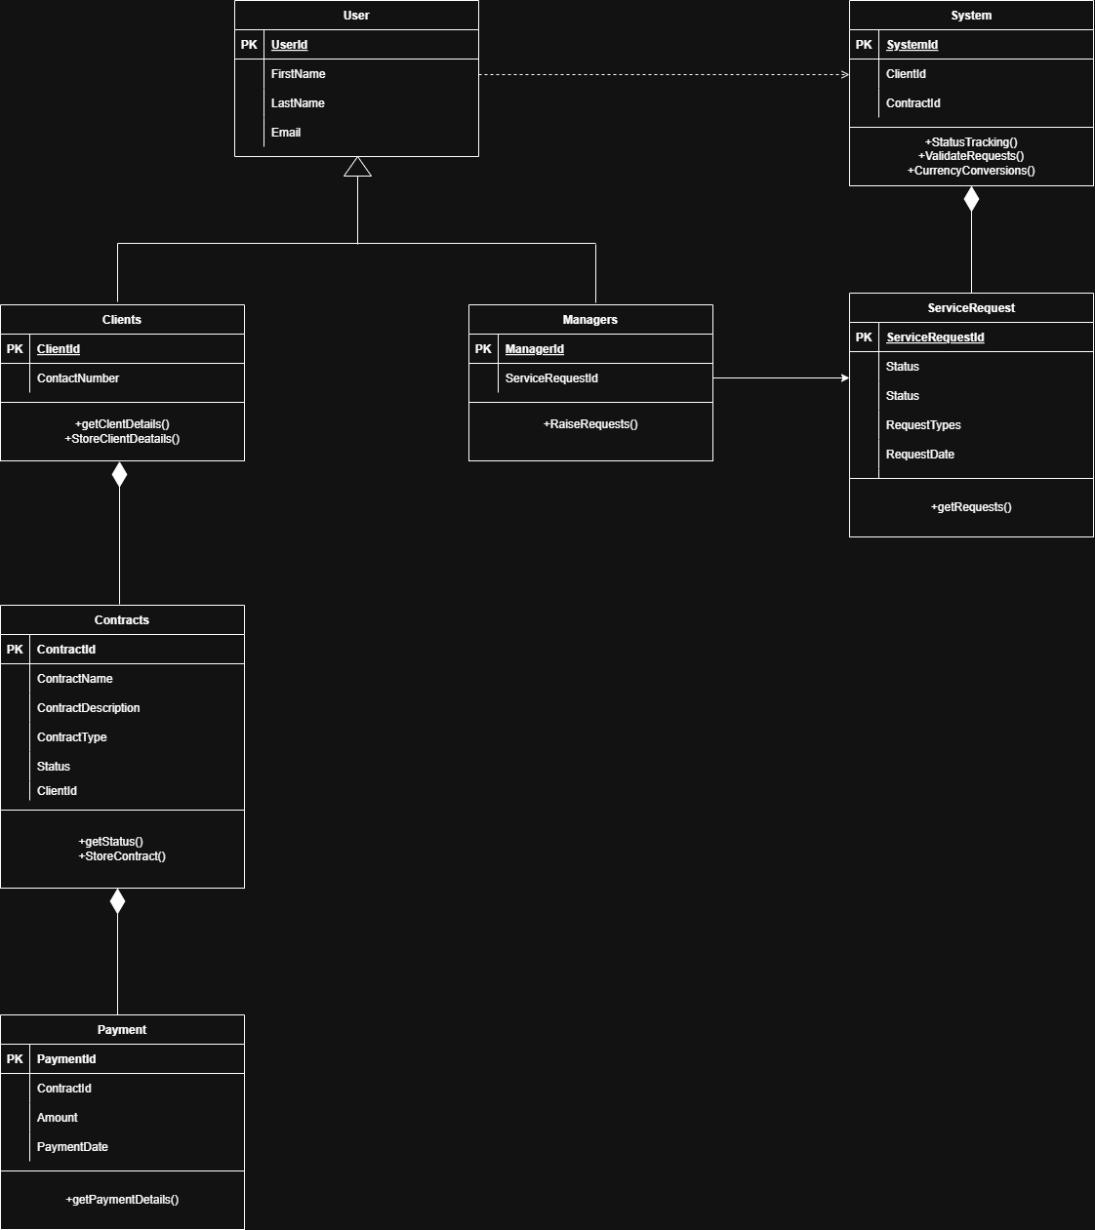

Availability and Interoperability:

Availability is the measure of how ready and reachable a system or service is to its users at any point in time. It indicates the percentage of time a system is available and working. (Kolberg. S, 2024). Usually, a system with high availability is a one that the users can utilize without encountering any major interruptions or downtimes. (Kolberg. S, 2024). Such a system is made possible by using redundancy, fault tolerance, and quick recovery mechanisms. (Kolberg. S, 2024).
- The Availability requirements for the system:

- Fault tolerance – the system should continue operating even if a component fails. (Yale, 2021).
- Disaster recovery – a disaster recovery plan must be implemented to restore services quickly in the case of system failure, cyber-attacks or natural disasters (Yale, 2021).
- Continuous Monitoring – The system should include real-time monitoring to detect failures or performance issues. (Yale, 2021).
Every computer on a network can connect with other computers through interoperability in order to share exchange combine and use data. (IBM ,2025). With minimal or no human involvement, each interoperable computer can also allow other computers to access update modify and analyse that data. (IBM ,2025). To achieve a common goal, it provides a seamless user experience while this information flows, making it easy to access different datasets. (IBM ,2025).

- The Interoperability requirements for the system:

- The system must support standard data formats such as XML, JSON and EDI, to enable consistent and reliable information exchange between software platforms. (Qualiware, 2024).
- Use of standardized interfaces (API’s) that enable communication and integration between various systems, ensuring that data is shared and processed across platforms. (Qualiware ,2024).

Scalability strategy

TechMove must have a system that can handle a sudden increase in users and data, without issues of downtime and performance issues. The system can counteract these kinds of issues, by the use of horizontal scaling, load balancing, and caching.
The process of expanding a system's capacity or performance by integrating more machines or servers to spread the load across a greater number of individual units is referred to as horizontal scaling, and the process of expanding the capacity or capabilities of a single hardware or software component inside a system is known as vertical scaling. (GeeksforGeeks, 2021). Horizontal scaling is a more suitable for this strategy, as a variety of servers or other nodes, that are needed, can be added as scalability is unlimited. (R. S. ,2024). Horizontal scaling offers easy maintenance for TechMove, as adding or removing servers, can be done one node at a time, while others continue to serve traffic, which minimizes downtime. Lastly, if one server fails in the system, then the others will continue to operate, which ensures high availability. (R. S. ,2024).

A load balancer is a technology that spreads network or application traffic among endpoints on several servers by acting as a traffic proxy. (GeeksforGeeks, 2023). Load balancers are used to improve application reliability and distribute capacity during situations of high demand. (GeeksforGeeks, 2023). Load balancers act as traffic directors, that evenly distribute incoming requests across multiple servers, ensuring no single sever becomes a bottleneck. They ensure that single points of failure are prevented, by detecting unhealthy nodes and routing traffic only to functional servers. (Cloudflare, 2024).

The concept of caching is to store frequently used data in a location that is quick and simple to access. When more servers are installed, traffic is frequently routed through a single database, creating a bottleneck, therefore frequently accessed data can be cached in memory (Redis, Memcached, etc.) to avoid database traffic. (GeeksforGeeks, 2021). Caching will also help the company, as their systems can quickly retrieve data that are requested by multiple users. ( Hazelcast, 2024). Lastly, distributed caching solutions (e.g., Redis) enables all servers in a horizontal scaled system to share the same cached data, which ensures consistency across the whole system and supports scalability as more servers are added. ( Hazelcast, 2024).

In conclusion, by using horizontal scaling, load balancing, and caching, TechMove can handle the increase of new contracts being added to the system as horizontal scaling allows for the adding or replacing of servers or other nodes effectively, without bringing the system down and, the system will continue to achieve high availability, even if a server or other node is down.

REFERENCING LIST

Site Point GmbH (2025). What is global logistics and supply chain management? [online] Available at: https://www.bertling.com/news-pool/blog/what-is-global-logistics/. [Accessed 10 March 2026].
White, S. (2022). What is TOGAF? An enterprise architecture methodology for business. [online] Available at: https://www.cio.com/article/228328/what-is-togaf-an-enterprise-architecture-methodology-for-business.html. [Accessed 10 March 2026].
GeeksforGeeks (2024). Enterprise Architect TOGAF(The Open Group Architecture Framework). [online]. Available at: https://www.geeksforgeeks.org/software-engineering/enterprise-architect-togafthe-open-group-architecture-framework/.[Accessed 10 March 2026].
Redhat (2021). Why TOGAF is so influential in enterprise architecture. [online] Available at: https://www.redhat.com/en/blog/TOGAF-importance. [Accessed 11 March 2026].
vpadmin (2024). The Strategic Advantage of TOGAF: Aligning IT and Business for Lasting Success - Visual Paradigm Guides. [online]. Available at: https://guides.visual-paradigm.com/the-strategic-advantage-of-togaf-aligning-it-and-business-for-lasting-success/. [Accessed 11 March 2026].
GeeksforGeeks (2017). State Design Pattern. [online]. Available at: https://www.geeksforgeeks.org/system-design/state-design-pattern/. [Accessed 12 March 2026].
Lee, S. (2025). State Pattern: A Game-Changer for Complex Systems. [online] Numberanalytics.com. Available at: https://www.numberanalytics.com/blog/state-pattern-game-changer-complex-systems/. [Accessed 12 March 2026].
chloe and chloe (2024). Managing Object State and Transitions with the State Pattern. [online] Available at: https://www.momentslog.com/development/design-pattern/managing-object-state-and-transitions-with-the-state-pattern/ [Accessed 13 Mar. 2026].
GeeksforGeeks (2016). Observer Design Pattern. [online]. Available at: https://www.geeksforgeeks.org/system-design/observer-pattern-set-1-introduction/. [Accessed 13 March 2026].
DEV Community. (2021). Understanding Design Patterns: Observer. [online] Available at: https://dev.to/carlillo/understanding-design-patterns-observer-2ajp. [Accessed 14 March 2026].
cpr_admin_1 (2024). Observer Pattern: Simplifying Event Handling and System Decoupling for Modern Software. [online]. Available at: https://curatepartners.com/tech-skills-tools-platforms/observer-pattern-simplifying-event-handling-and-system-decoupling-for-modern-software/. [Accessed 14 March 2026].

GeeksforGeeks (2016). Decorator Design Pattern. [online]. Available at: https://www.geeksforgeeks.org/system-design/decorator-pattern/. [Accessed 15 March 2026].
Kumar, A. (2024). Decorator Design Pattern. [online] Medium. Available at: https://medium.com/@adarsh_tech/decorator-design-pattern-28e45364bed2/. [Accessed 15 March 2026].
Aamol Gote (2014). Validations through Decorator Pattern. [online] Available at: https://mytechnetknowhows.wordpress.com/2014/10/19/validations-through-decorator-pattern/ [Accessed 15 March 2026].
Kolberg, S. (2024). Interoperability & Availability: Cybersecurity Foes or Allies? [online] Available at: https://www.belden.com/blog/interoperability-availability-cybersecurity-foes-or-allies. [Accessed 19 March 2026].
IBM (2025). Interoperability. [online]. Available at: https://www.ibm.com/think/topics/interoperability. [Accessed 19 March 2026].
Qualiware (2024). Interoperability Requirements | QualiWare Center of Excellence. [online] Available at: https://coe.qualiware.com/resources/togaf/9-1/part3-admguide/interoperability-requirements/. [Accessed 19 March 2026].
Yale. (2021). Availability Requirement Guideline. [online] Available at: https://cybersecurity.yale.edu/availability-requirement. [Accessed 19 March 2026].
GeeksforGeeks (2021). Horizontal and Vertical Scaling | System Design. [online]. Available at: https://www.geeksforgeeks.org/system-design/system-design-horizontal-and-vertical-scaling/. [Accessed 23 March 2026].
R, S. (2024). Horizontal scaling vs vertical scaling: Choosing your strategy | DigitalOcean. [online] Available at: https://www.digitalocean.com/resources/articles/horizontal-scaling-vs-vertical-scaling. [Accessed 23 March 2026].
GeeksforGeeks (2023). What is Load Balancer & How Load Balancing works? [online]. Available at: https://www.geeksforgeeks.org/system-design/what-is-load-balancer-system-design/. [Accessed 24 March 2026].
GeeksforGeeks (2021). Caching System Design Concept. [online]. Available at: https://www.geeksforgeeks.org/system-design/caching-system-design-concept-for-beginners/. [Accessed 25 March 2026].
Hazelcast. (2024). Caching. [online] Available at: https://hazelcast.com/foundations/caching/caching/. [Accessed 25 March 2026].
‌

‌

‌

‌

‌

‌

‌

‌

‌

‌

‌

‌

‌

‌

‌
‌

